A UDL Thought Exercise
This thought exercise is designed to help you take stock of a course you have taught or are considering teaching, or an interaction in which you support learners. Take a minute and, thinking about one of your own courses or student interactions, not your responses on the worksheet below.

Name of Course/ Interaction: ___________________________________________________

List Your Learning Goals:

- _______________________________________________________________________________________________________________

- _______________________________________________________________________________________________________________

- _______________________________________________________________________________________________________________

List Your Objectives:

- _______________________________________________________________________________________________________________

- _______________________________________________________________________________________________________________

- _______________________________________________________________________________________________________________
 | Pinch Point | +1 Strategy | Resources Needed
Course Design (single-stream materials)

Instructional Approach (Means of interacting with learners)

Assessment Plans (Assessments that requires learners to demonstrate their skills in only one format)

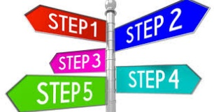
Planning My Next Steps
Use this worksheet to think about your UDL efforts over the next 20 days and 20 months. These strategies might be more involved than the strategies we worked through today.

The Next 20 Days:
Strategy | What resources do you need to implement it?

The Next 20 Months:
Strategy | What resources do you need to implement it?

